Excel Sims…
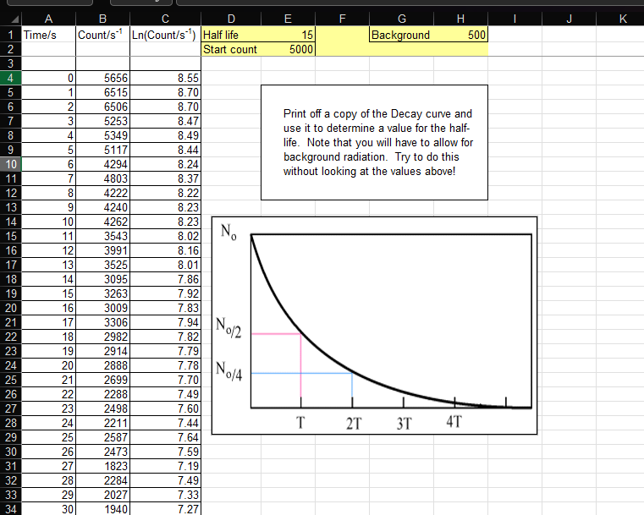
These old Excel sims are collected from a few sources, some are my own making. I hope they are useful:
Binding Energy Curve
Cooling and insulation
Radioactive decay curve
Radioactive background charts
UK Radiation exposure data
Coils on electromagnet
Radio telescope images
Simulated damped oscillations
Spring energy simulation
Stopping Distances
Terminal Velocity Parachute

